President Barack Obama
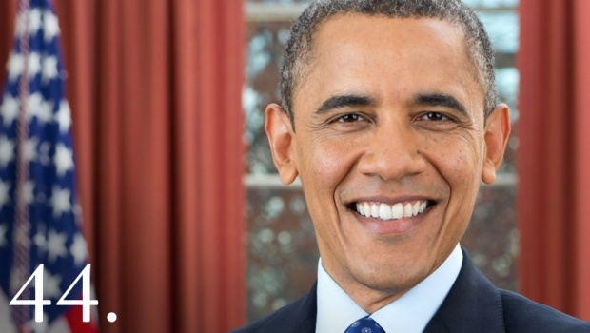

- President Barack Obama was born Barack Hussein Obama II on August 4, 1961 in Honolulu Hawaii.
- Barack Obama became the 44th President on January 20th 2009.
- He was the first African American President of the United States
- He attended the Punahou school in Hawaii. In school he had the nickname “O”Bomer because he was a really good basketball player.
- He graduated from the Punahou school in 1979.
- After graduation he attended Occidental College in Los Angeles.
- in 1981 he transferred to Columbia University in New York. He graduated in 1983.
- Barack Obama wanted to get into law and entered Harvard Law School in 1988. He graduated from Harvard in 1991.
- He moved to Chicago and became a civil rights lawyer and taught constitutional law at the University of Chicago Law School from 1992-2004.
- He met Michelle Robinson who was also working in a law office.
- Barack and Michelle got married on October 18, 1992.
- They have two children Malia and Sasha.
- In 1992 Barack was the director of Project Vote. It was a campaign to get minorities registered to vote. Under his direction 150,000 African Americans were registered to vote.
- In 1993 Barack worked as director of the Developing Communities Project. It was a community organization. He helped set up job training, college prep tutoring and a tenants rights organization.
- In 1996 Barack Obama ran for Senate in the state of Illinois. He won and served as senator until 2004.
- In 2006 Barack Obama won a Grammy for his autobiography Dreams from My Father.
- He entered the presidential election in 2008 as a Democrat.
- He won the election and was inaugurated on January 20, 2008.
- An estimated 2 million people came to watch his inauguration, the most in history.
- When Barack Obama became president he kept his promise to Malia and Sasha and got a dog.
- The family dog is named Bo. He is a Portuguese Water dog and he is black and white.
- Barack Obama won a Nobel Peace Prize in 2009 for his “extraordinary” efforts at international diplomacy and foreign policy.
- Barack Obama reformed health care by passing the Patient Protection Act and Affordable Care Act on March 23, 2010.
- Barack Obama won a second term as president in 2012.

