Name:__________________________

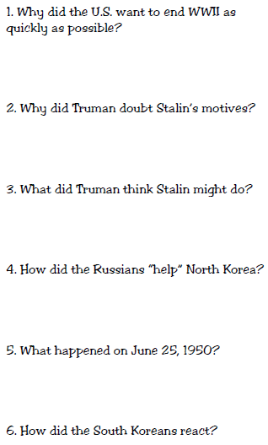

7. Who came to the aid of South Korea?

8. How was the necessary unanimous vote accomplished?

