Barack Obama Webquest
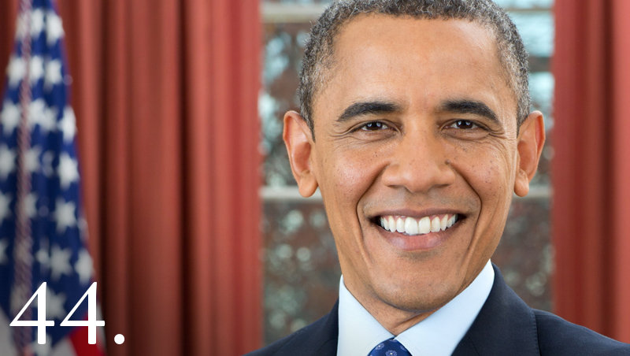
http://www.history.com/topics/us-presidents/barack-obama
Directions: Complete the following questions by using the website above.
1. What was the name of President Obama’s father and where did he grow
up?
2. Who was President Obama’s mother and where was she from?
3. When and where was President Obama born?
4. According to the website, Obama’s presidential election was the first for a
number of different things. Explain at least two.
5. What occurred to President Obama’s father in 1982?
6. After his mother remarried, where did she and President Obama move to
in the late 1960s?
7. Who did Obama live with when he returned to Hawaii in 1970?
8. He attended the Punahou School, an elite private school where, as he
wrote in his 1995 memoir, ______________________________, he first began to
understand __________________________________________________. After two
years at Occidental College in Los Angeles, he transferred to ____________
________________________________________________________________________
______________________________________________________________________.
9. What job did Obama have when he went to Chicago in the 1980s?
10. Explain his role in the job from question #9.
11. What did Obama do in 1996? Explain.
12. According to the website, what achievement(s) did he have while in the
Senate?
13. Re-elected in _________________________________________________________
________________________________________________________________________
_____________________________________________________. As a state senator,
Obama notably went on record as an early opponent of President
George W. Bush’s ___________________________. During a rally at Chicago’s
Federal Plaza in October 2002, he spoke against a resolution authorizing
the use of force against Iraq: “_________________________________________
________________________________________________________________________
________________________________________________________________________
______________________________________________________________________.”
14. What caused Obama to become a recognizable figure on the national
stage in 2004?
15. What was significant about Obama’s Senate victory in 2004?
16. What issues did he focus on as a Senator?
17. When did Obama officially announce his candidacy for the 2008
presidential election?
18. Who was his primary challenger in the Democratic Party?
19. Who did Obama choose as his running mate in the election? Explain his
political past.
20. Who was the Republican candidate for the election in 2008? Explain his
political past.
21. Who served as the Vice President Candidate for the Republican Party in
2008?
22. According to the website, how did Obama gain support during the
election process?
23. A _______________________ in the months leading up to the election shifted
the nation’s focus to economic issues, and both Obama and McCain
worked __________________________________________________________. With
several weeks remaining, most polls showed Obama as the frontrunner.
Sadly, _________________________________________________________________
________________________________________________________________________
_____. She had been a tremendously influential force in her grandson’s life
and had diligently followed his historic run for office from her home in
Honolulu.
24. Obama won the election on November 4th. According to the website,
what key states helped propel him to the Presidency?
25. Why was Obama’s 2008 election victory so significant?

